|  |  |
| --- | --- |
| Институт (факультет) | Институт информационных технологий |
| Кафедра | Кафедра математического и программного обеспечения ЭВМ |

# РАЗРАБОТКА АБСТРАКТНЫХ ТИПОВ ДАННЫХ

|  |  |
| --- | --- |
| **Дисциплина:** | ООП |
| **Темы:** | **Программирование обработки исключительных ситуаций** |

**Среда разработки:** Microsoft Visual Studio

**Язык программирования:** C++

**Тип проекта:** Консольное приложение

**ТРЕБОВАНИЯ К РАЗРАБОТКЕ**

1. Каждый класс должен быть оформлен в отдельных файлах: заголовочный (.h) и файл с кодом (.cpp).
2. Запрещается использовать обработку исключительных ситуаций и генерировать исключения.
3. Придерживайтесь принципа DRY (Don’t repeat yourself).
4. Обязательно наличие комментариев.

Схема:

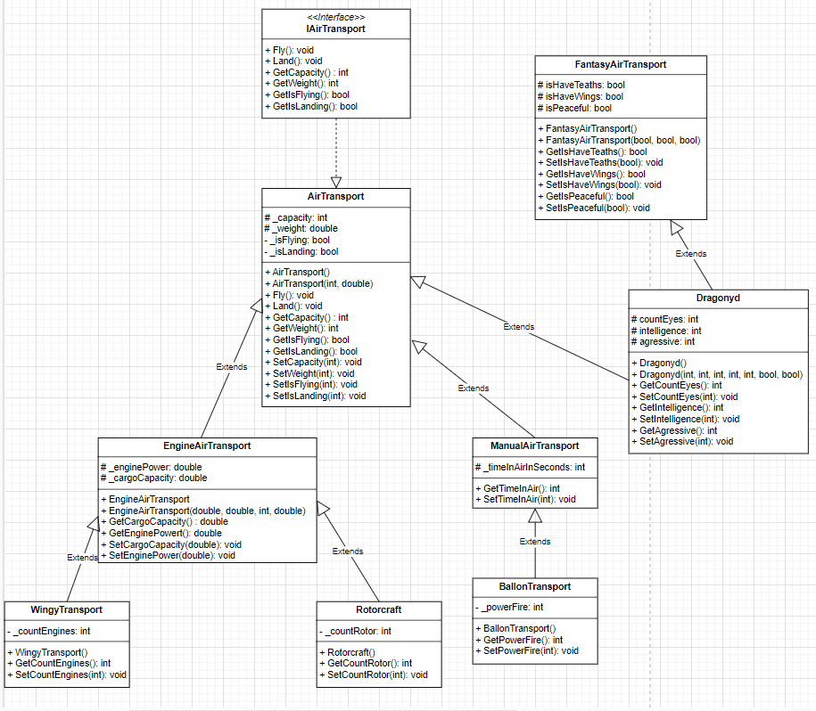

Код:

sem2.cpp

#include <iostream>

#include "AirTransport.h"

#include "EngineAirTransport.h"

#include "WingyTransport.h"

#include "Rotorcraft.h"

#include "BallonTransport.h"

#include "Dragonyd.h"

using namespace std;

void getCapacity(IAirTransport& transport) {

cout << "Вместимость: " << transport.GetCapacity() << endl;

}

void getEnginePower(EngineAirTransport tranport) {

cout << "Мощность двигателя: " << tranport.GetEnginePower() << endl;

}

int main()

{

setlocale(LC_ALL, "rus");

WingyTransport wingy;

Rotorcraft helicopter;

BallonTransport ballon;

Dragonyd dragon;

getCapacity(wingy);

getCapacity(helicopter);

getCapacity(ballon);

getCapacity(dragon);

getEnginePower(wingy);

getEnginePower(helicopter);

try {

dragon.SetCountEyes(-100);

}

catch (invalid_argument ex) {

cout « «ПОЙМАНО ИСКЛЮЧЕНИЕ:» << ex.what() << endl;

}

}

IAirTransport.h

#pragma once

class IAirTransport

{

public:

/// <summary>Возвращает вместимость транспорта.</summary>

/// <returns>Вместимость транспорта.</returns>

virtual int GetCapacity() = 0;

/// <summary>Возвращает вес транспорта.</summary>

/// <returns>Вес транспорта.</returns>

virtual double GetWeight() = 0;

/// <summary>Возвращает в воздухе ли транспорт.</summary>

/// <returns>Воздухе ли транспорт.</returns>

virtual bool GetIsFlying() = 0;

/// <summary>Возвращает приземлился ли транспорт.</summary>

/// <returns>Приземлился ли транспорт.</returns>

virtual bool GetIsLanding() = 0;

/// <summary>Позволяет взлететь.</summary>

virtual void Fly() = 0;

/// <summary>Приземлиться.</summary>

virtual void Land() = 0;

};

AirTransport.h

#pragma once

#include "IAirTransport.h"

class AirTransport : public IAirTransport

{

private:

bool _isFlying;

bool _isLanding;

protected:

int _capacity;

double _weight;

public:

AirTransport();

/// <summary>Создание объекта AirTransport.</summary>

/// <param name="capacity">Вместимость.</param>

/// <param name="weight">Вес.</param>

AirTransport(int capacity, double weight);

/// <summary>Возвращает вместимость транспорта.</summary>

/// <returns>Вместимость транспорта.</returns>

int GetCapacity();

/// <summary>Задает вместимость транспорта.</summary>

/// <param name="capacity">Вместимость транспорта.</param>

void SetCapacity(int capacity);

/// <summary>Возвращает вес транспорта.</summary>

/// <returns>Вес транспорта.</returns>

double GetWeight();

/// <summary>Задает вес транпорта.</summary>

/// <returns>Вес транспорта.</returns>

void SetWeight(double weight);

/// <summary>Возвращает в воздухе ли транспорт.</summary>

/// <returns>Воздухе ли транспорт.</returns>

bool GetIsFlying();

/// <summary>Возвращает приземлился ли транспорт.</summary>

/// <returns>Приземлился ли транспорт.</returns>

bool GetIsLanding();

/// <summary>Позволяет взлететь.</summary>

void Fly();

/// <summary>Приземлиться.</summary>

void Land();

};

AirTransport.cpp

#include "airTransport.h"

#include <exception>

#include "CheckValidation.h"

using namespace std;

AirTransport::AirTransport()

{

_weight = 100;

_capacity = 100;

_isFlying = false;

_isLanding = true;

}

AirTransport::AirTransport(int capacity, double weight)

{

_capacity = CheckValidation::CheckNegative(capacity);

_weight = CheckValidation::CheckNegative(weight);

_isFlying = false;

_isLanding = true;

}

int AirTransport::GetCapacity()

{

return _capacity;

}

void AirTransport::SetCapacity(int capacity)

{

_capacity = CheckValidation::CheckNegative(capacity);

}

double AirTransport::GetWeight()

{

return _weight;

}

void AirTransport::SetWeight(double weight)

{

_weight = CheckValidation::CheckNegative(weight);

}

bool AirTransport::GetIsFlying()

{

return _isFlying;

}

bool AirTransport::GetIsLanding()

{

return _isLanding;

}

void AirTransport::Fly()

{

_isFlying = true;

_isLanding = false;

}

void AirTransport::Land()

{

_isFlying = false;

_isLanding = true;

}

EngineAirTransport.h

#pragma once

#include "AirTransport.h"

class EngineAirTransport : public AirTransport

{

protected:

double _enginePower;

double _cargoCapacity;

public:

EngineAirTransport(double enginePower, double cargoCapacity, double capacity, int weight);

EngineAirTransport(double enginePower, double cargoCapacity);

EngineAirTransport();

double GetEnginePower();

double GetCargoCapacity();

void SetEnginePower(double enginePower);

void SetCargoCapacity(double cargoCapacity);

};

EngineAirTransport.cpp

#include "EngineAirTransport.h"

#include "CheckValidation.h"

EngineAirTransport::EngineAirTransport(double enginePower, double cargoCapacity, double capacity, int weight) : AirTransport(capacity, weight)

{

_cargoCapacity = CheckValidation::CheckNegative(cargoCapacity);

_enginePower = CheckValidation::CheckNegative(enginePower);

}

EngineAirTransport::EngineAirTransport(double enginePower, double cargoCapacity) : AirTransport()

{

_cargoCapacity = CheckValidation::CheckNegative(cargoCapacity);

_enginePower = CheckValidation::CheckNegative(enginePower);

}

EngineAirTransport::EngineAirTransport() : AirTransport()

{

_cargoCapacity = 20;

_enginePower = 200;

}

double EngineAirTransport::GetEnginePower()

{

return _enginePower;

}

double EngineAirTransport::GetCargoCapacity()

{

return _cargoCapacity;

}

void EngineAirTransport::SetEnginePower(double enginePower)

{

_enginePower = CheckValidation::CheckNegative(enginePower);

}

void EngineAirTransport::SetCargoCapacity(double cargoCapacity)

{

_cargoCapacity = CheckValidation::CheckNegative(cargoCapacity);

}

BallonTransport.h

#pragma once

#include "ManualAirTransport.h"

class BallonTransport : public ManualAirTransport

{

private:

int _powerFire;

public:

BallonTransport();

int GetPowerFire();

void SetPowerFire(int powerFire);

};

BallonTransport.cpp

#include "BallonTransport.h"

BallonTransport::BallonTransport() : ManualAirTransport()

{

_powerFire = 45;

}

int BallonTransport::GetPowerFire()

{

return _powerFire;

}

void BallonTransport::SetPowerFire(int powerFire)

{

_powerFire = powerFire;

}

WingyTransport.h

#pragma once

#include "EngineAirTransport.h"

class WingyTransport : public EngineAirTransport

{

private:

int _countEngines;

public:

WingyTransport();

int GetCountEngines();

void SetCountEngines(int countEngines);

};

WingyTransport.cpp

#include "WingyTransport.h"

#include "CheckValidation.h"

WingyTransport::WingyTransport() : EngineAirTransport()

{

_countEngines = 4;

}

int WingyTransport::GetCountEngines()

{

return _countEngines;

}

void WingyTransport::SetCountEngines(int countEngines)

{

_countEngines = CheckValidation::CheckNegative(countEngines);

}

Rotorcraft.h

#pragma once

#include "EngineAirTransport.h"

class Rotorcraft : public EngineAirTransport

{

private:

int _countRotor;

public:

Rotorcraft();

int GetCountRotor();

void SetCountRotor(int countRotor);

};

Rotorcraft.cpp

#include "Rotorcraft.h"

#include "CheckValidation.h"

Rotorcraft::Rotorcraft() : EngineAirTransport()

{

_countRotor = 4;

}

int Rotorcraft::GetCountRotor()

{

return _countRotor;

}

void Rotorcraft::SetCountRotor(int countRotor)

{

_countRotor = CheckValidation::CheckNegative(countRotor);

}

FantasyAirTransport.h

#pragma once

class FantasyAirTransport

{

protected:

bool isHaveTeaths;

bool isHaveWings;

bool isPeaceful;

public:

FantasyAirTransport();

FantasyAirTransport(bool isHaveTeaths, bool isHaveWings, bool isPeaceful);

bool GetIsHaveTeaths();

void SetIsHaveTeaths(bool isHaveTeaths);

bool GetIsHaveWings();

void SetIsHaveWings(bool isHaveWings);

bool GetIsPeaceful();

void SetIsPeaceful(bool isPeaceful);

};

FantasyAirTransport.cpp

#include "FantasyAirTransport.h"

FantasyAirTransport::FantasyAirTransport()

{

isHaveTeaths = isHaveWings = isPeaceful = false;

}

FantasyAirTransport::FantasyAirTransport(bool isHaveTeaths, bool isHaveWings, bool isPeaceful)

{

this->isHaveTeaths = isHaveTeaths;

this->isHaveWings = isHaveWings;

this->isPeaceful = isPeaceful;

}

bool FantasyAirTransport::GetIsHaveTeaths()

{

return isHaveTeaths;

}

void FantasyAirTransport::SetIsHaveTeaths(bool isHaveTeaths)

{

this->isHaveTeaths = isHaveTeaths;

}

bool FantasyAirTransport::GetIsHaveWings()

{

return isHaveWings;

}

void FantasyAirTransport::SetIsHaveWings(bool isHaveWings)

{

this->isHaveWings = isHaveWings;

}

bool FantasyAirTransport::GetIsPeaceful()

{

return isPeaceful;

}

void FantasyAirTransport::SetIsPeaceful(bool isPeaceful)

{

this->isPeaceful = isPeaceful;

}

Dragonyd.h

#pragma once

#include "AirTransport.h"

#include "FantasyAirTransport.h"

class Dragonyd : public AirTransport, public FantasyAirTransport

{

protected:

int countEyes;

int intelligence;

int agressive;

public:

Dragonyd();

Dragonyd(int count, int intelligence, int agressive, int capacity, int weight, bool isHaveWings, bool isPeaceful);

int GetCountEyes();

void SetCountEyes(int count);

int GetIntelligence();

void SetIntelligence(int intelligence);

int GetAgressive();

void SetAgressive(int agressive);

};

Dragonyd.cpp

#include "Dragonyd.h"

#include "CheckValidation.h"

Dragonyd::Dragonyd() : FantasyAirTransport(), AirTransport(5, 200)

{

countEyes = 2;

intelligence = 40;

agressive = 70;

}

Dragonyd::Dragonyd(int count,

int intelligence,

int agressive,

int capacity,

int weight,

bool isHaveWings,

bool isPeaceful) : AirTransport(capacity, weight), FantasyAirTransport(true, isHaveWings, isPeaceful)

{

this->countEyes = CheckValidation::CheckNegative(count);

this->intelligence = CheckValidation::CheckNegative(intelligence);

this->agressive = CheckValidation::CheckNegative(agressive);

}

int Dragonyd::GetCountEyes()

{

return countEyes;

}

void Dragonyd::SetCountEyes(int count)

{

this->countEyes = CheckValidation::CheckNegative(count);

}

int Dragonyd::GetIntelligence()

{

return intelligence;

}

void Dragonyd::SetIntelligence(int intelligence)

{

this->intelligence = CheckValidation::CheckNegative(intelligence);

}

int Dragonyd::GetAgressive()

{

return agressive;

}

void Dragonyd::SetAgressive(int agressive)

{

this->agressive = CheckValidation::CheckNegative(agressive);

}

Тесты:

